Research Current Top-Ranking Pins SOP
Before creating pins, use an incognito tab to see what’s already ranking.
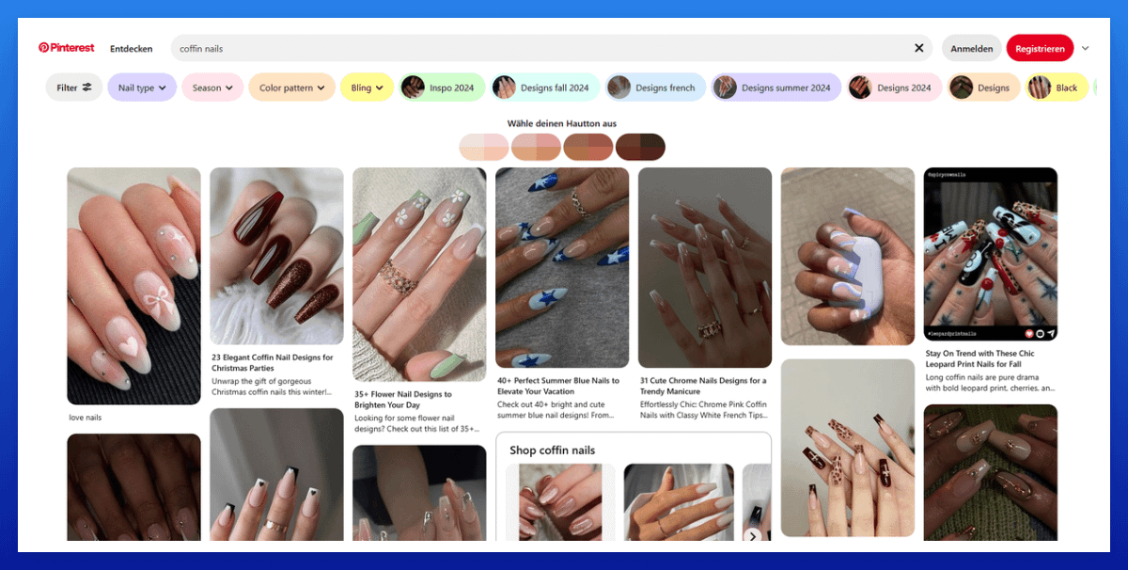

Look at:
- The dominant pin formats (collage, plain image or text overlays?)
- The color schemes (these can make a big difference)
- If product pins or ads dominate (not a good sign when you want to promote your article)
  - If it's mostly product pins or ads, skip the KW
- The common title formats
Use this data to get inspired and create your pins in a similar style.

Use:
- The pin format that dominates (collage, plain image, or text overlays)
- The color scheme that dominates
- Similar title patterns

